**Note: It’s continuity of Internet gateway lab, Need to delete the Nat gateway and release the Elastic IP once scenario has been completed. Otherwise charges will be applicable for Elastic IP. If you are facing any challenges please contact our whatsapp group.**

Lab: Need to access internet from Private Network.

Goto EC2 Dashboard, select instances and click **“Launch Instance”**

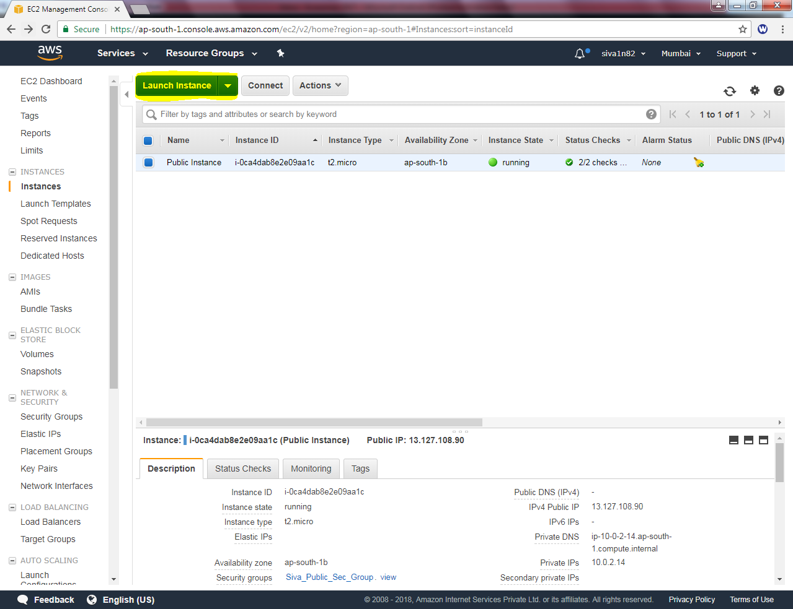

In AMI, select “Microsoft windows server 2016-Base”

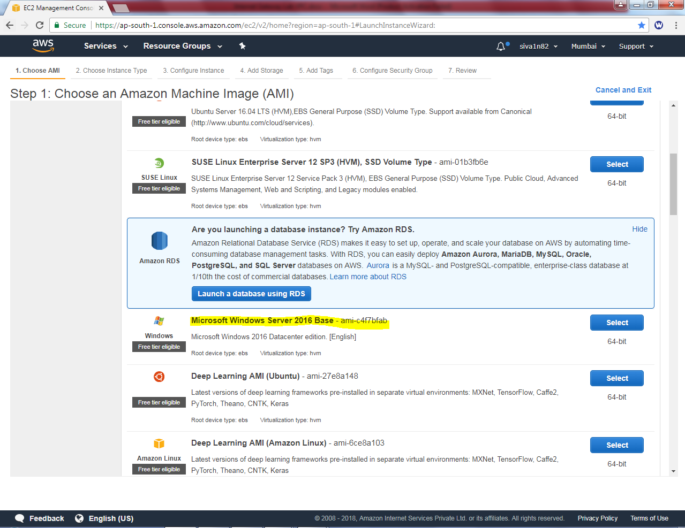

In Configure instance, Select **“Siva_VPC”** in network, ”**Siva_Private_Subnet”** in Subnet and “Disable“ option in Auto-assign Public IP.

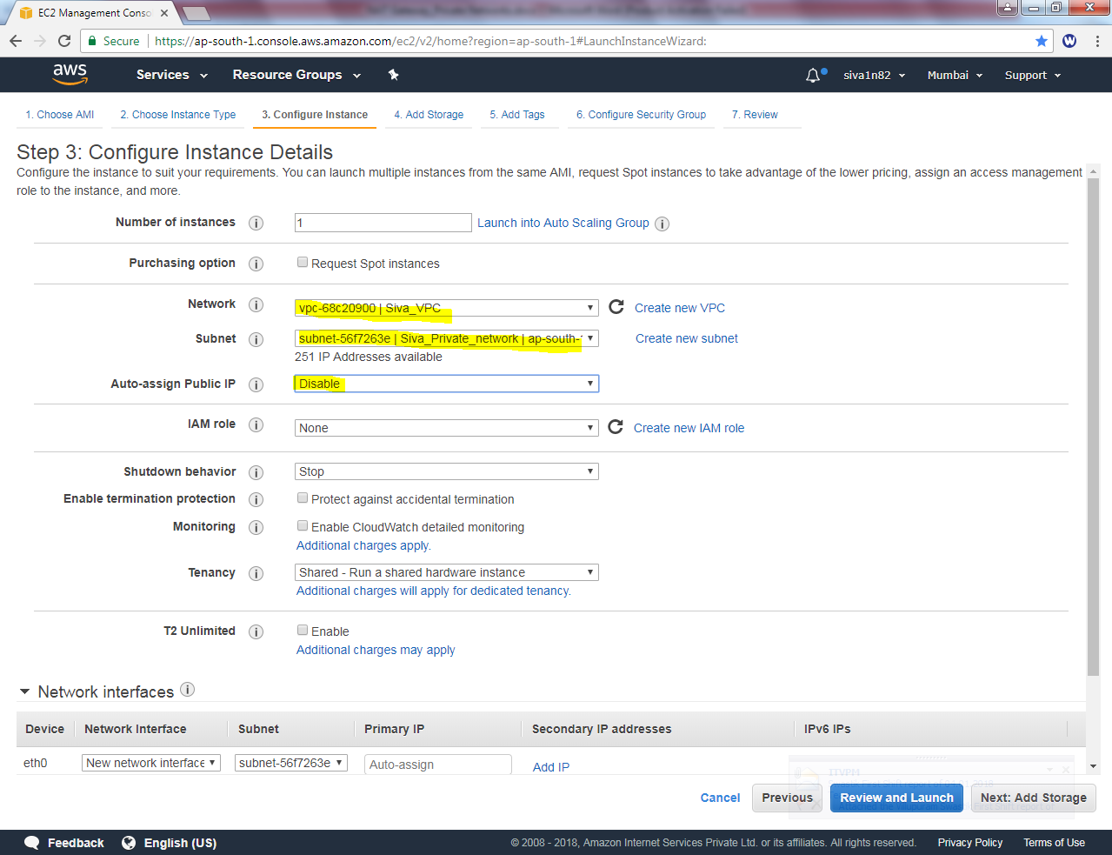

Click “Next”.

Leave the settings as default

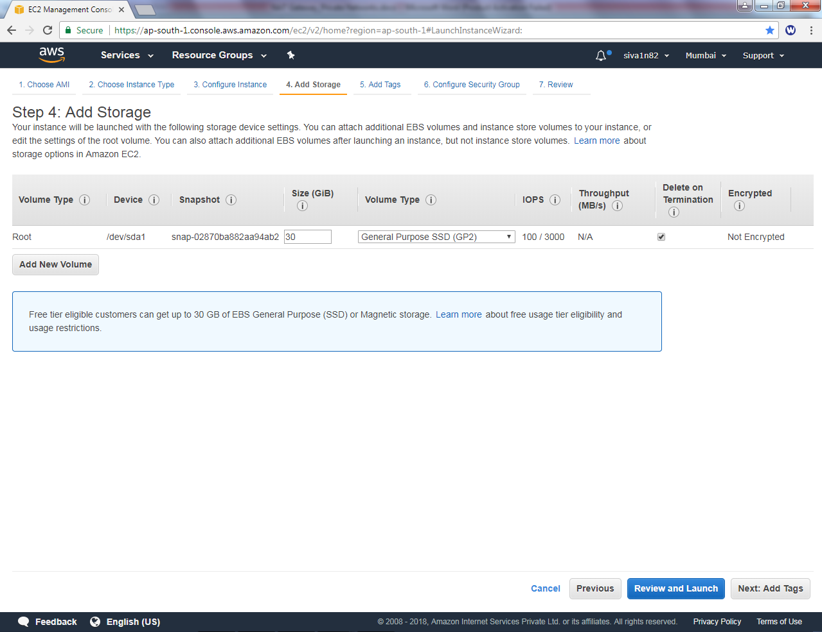

Click “Next”.

In Add tag, Key value as “Name” and Value as “Private Instance”.

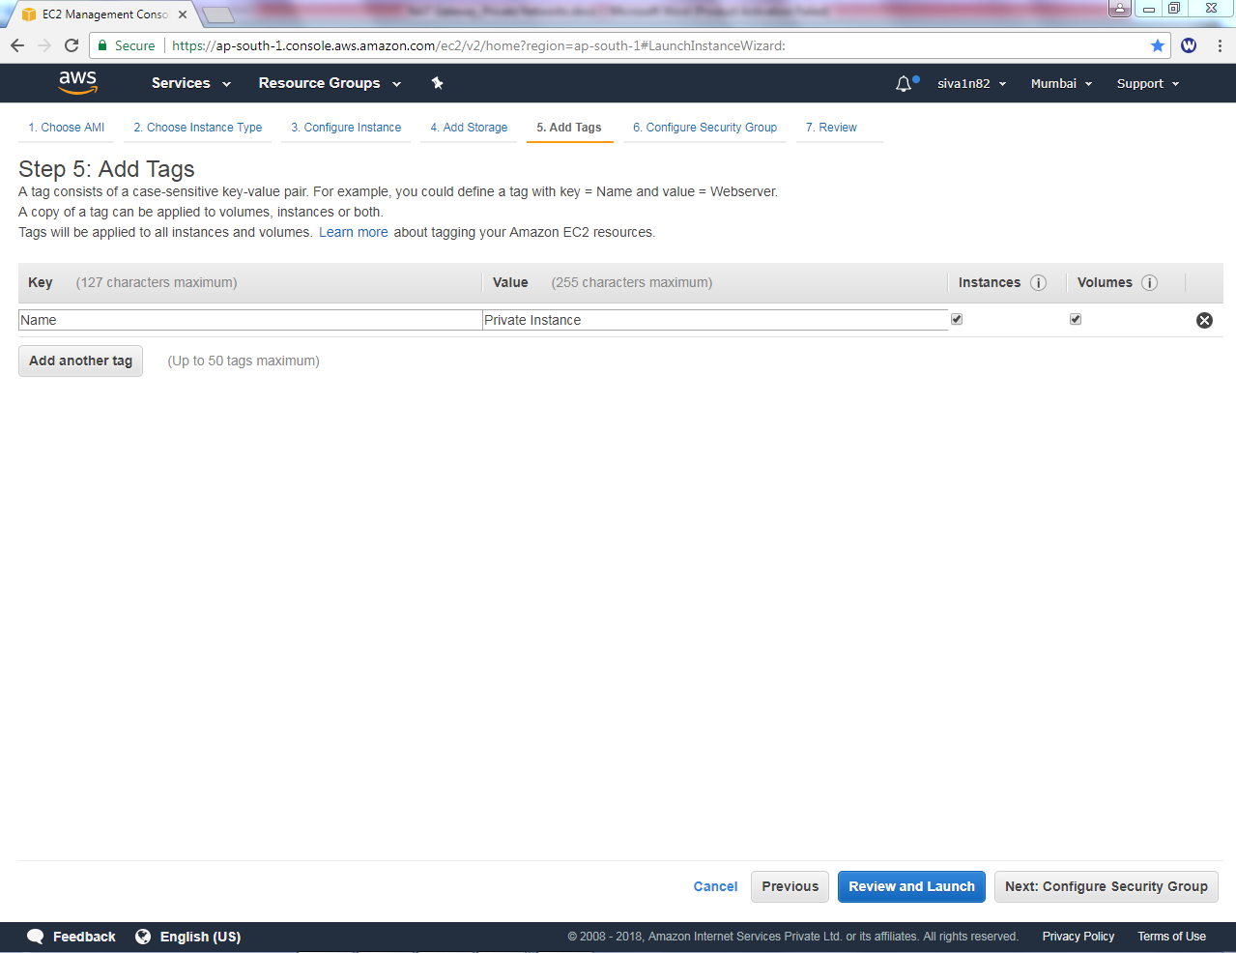

In Configure security group, select “Siva_Public_Sec_Group”.

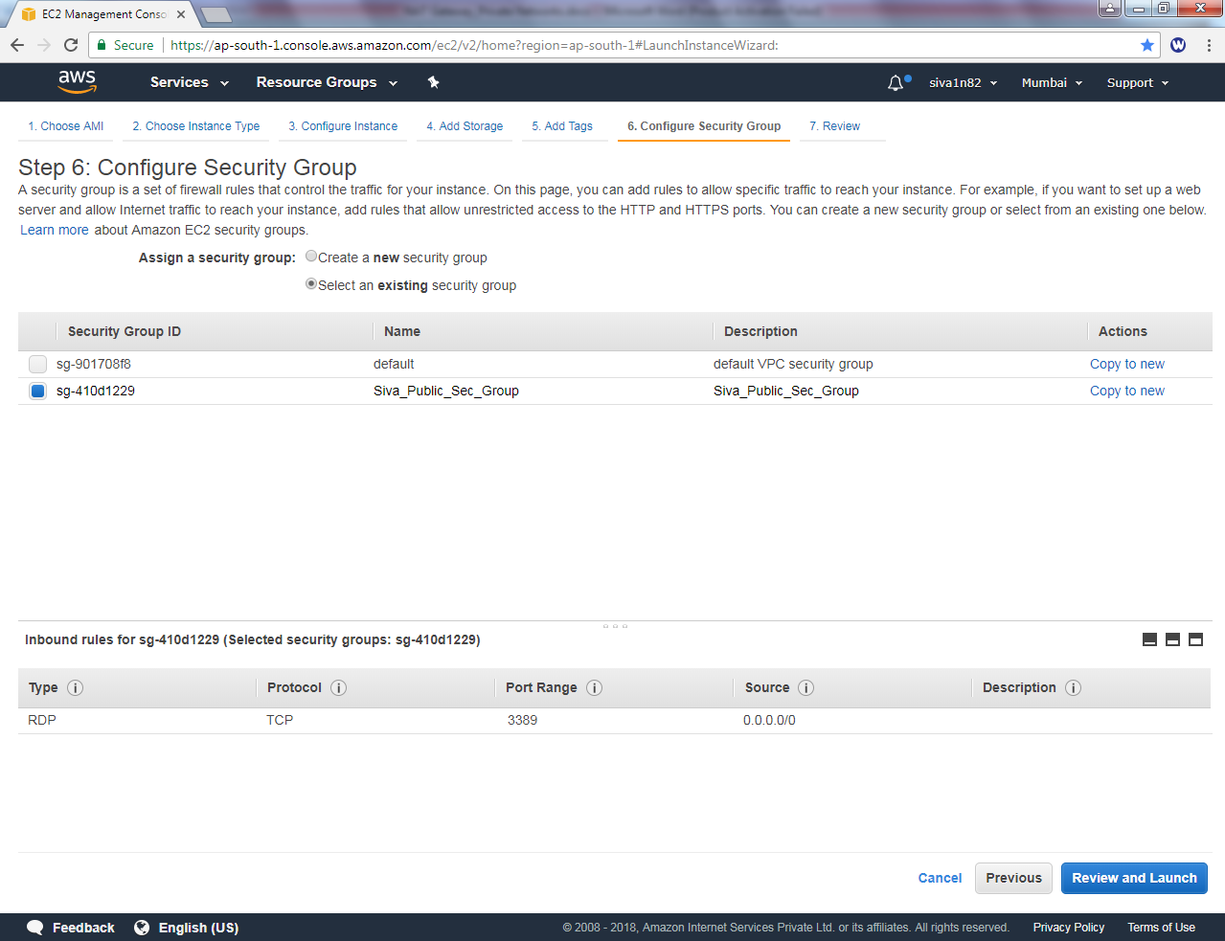

Click “Review and Launch”.

Leave the settings as default.

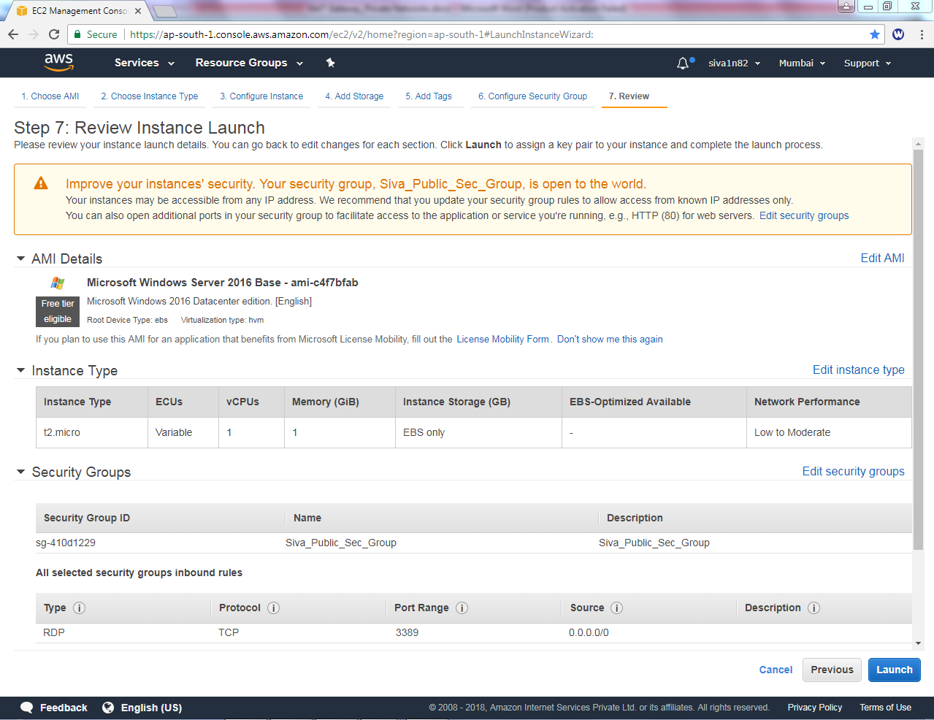

Click “Launch”.

Select a existing key pair and select the key pair. Acknowledge the access of key.

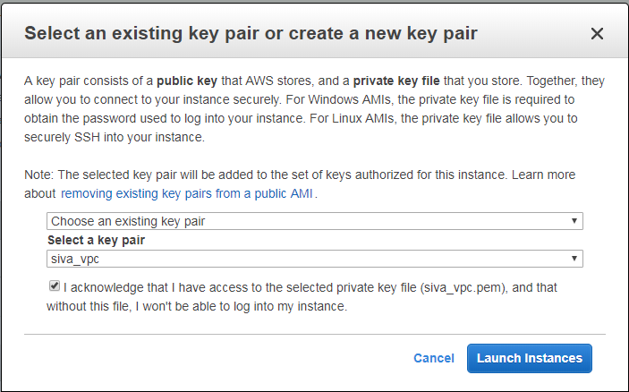

Then click “Launch Instance”.

Try to connect 10.0.1.204 (private subnet host) from Public subnet host.

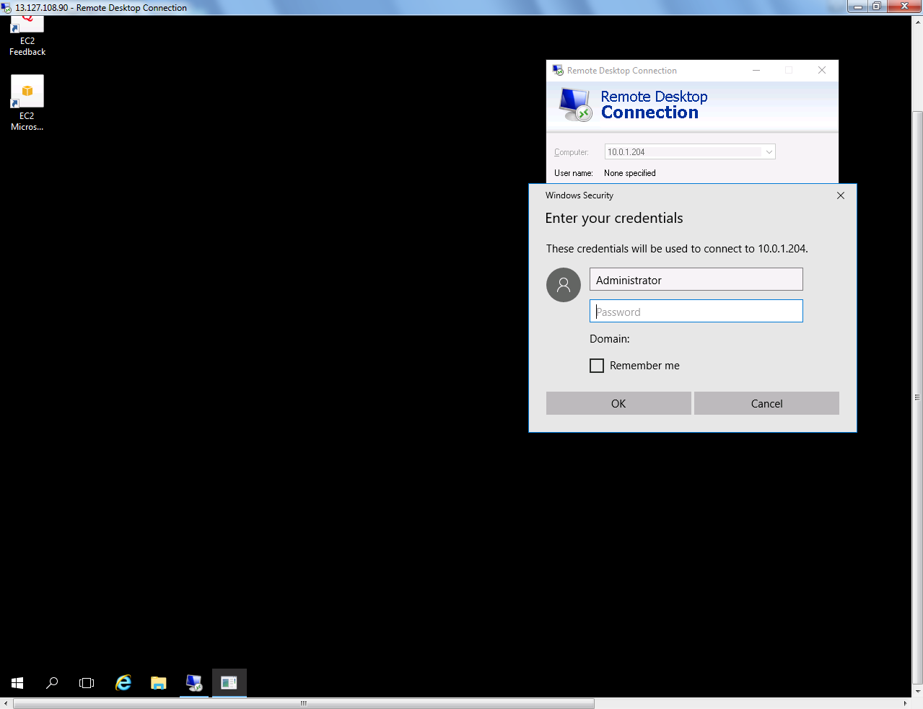



Kindly try to connect internet from 10.0.1.204 machine.

But, you are not able to connect Internet. Because you are in private network, need to configure NAT Gateway in VPC.

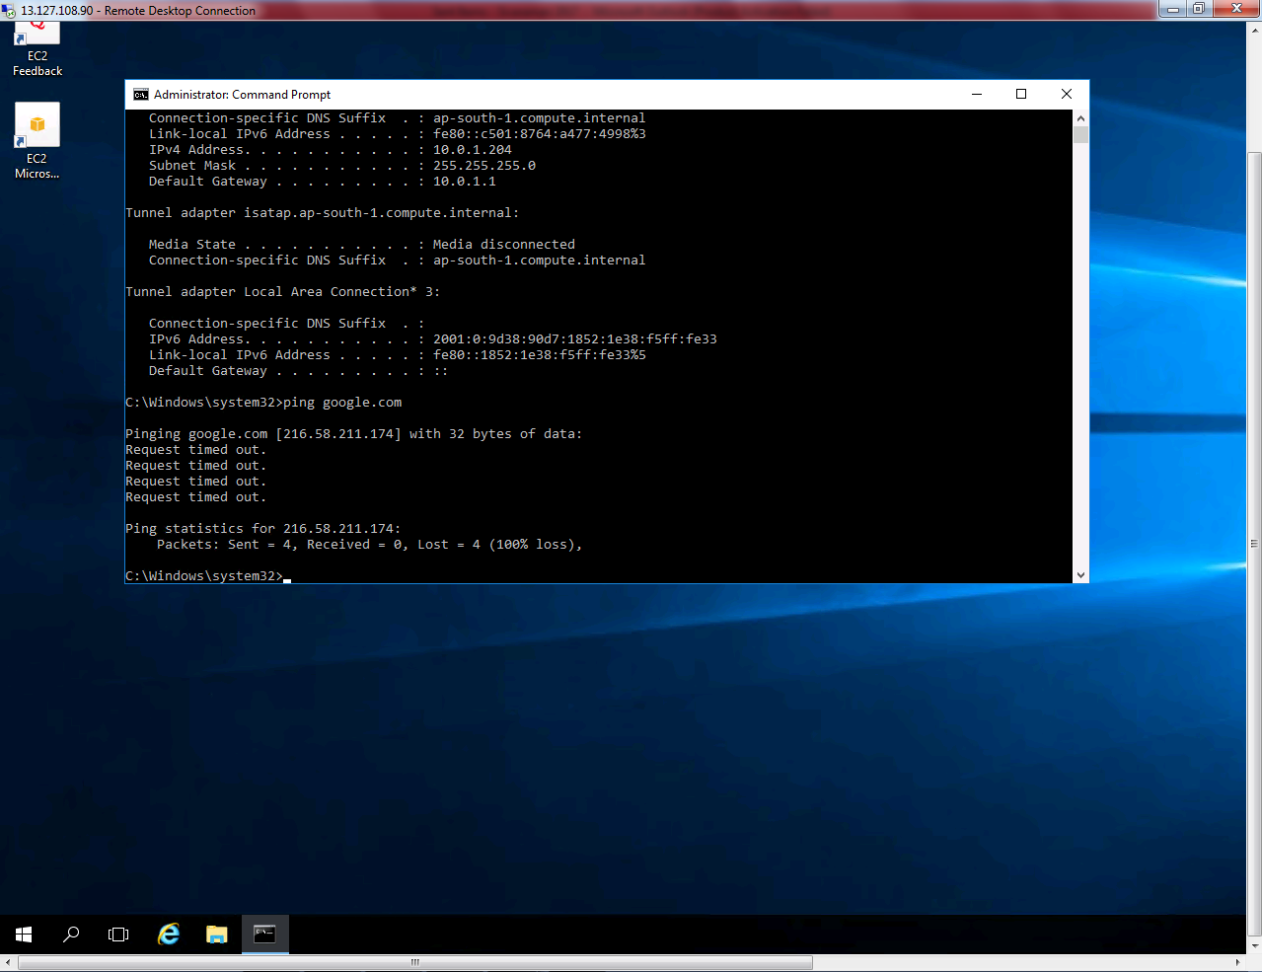

Go to, VPC Dashboard, Select “Nat Gateways”

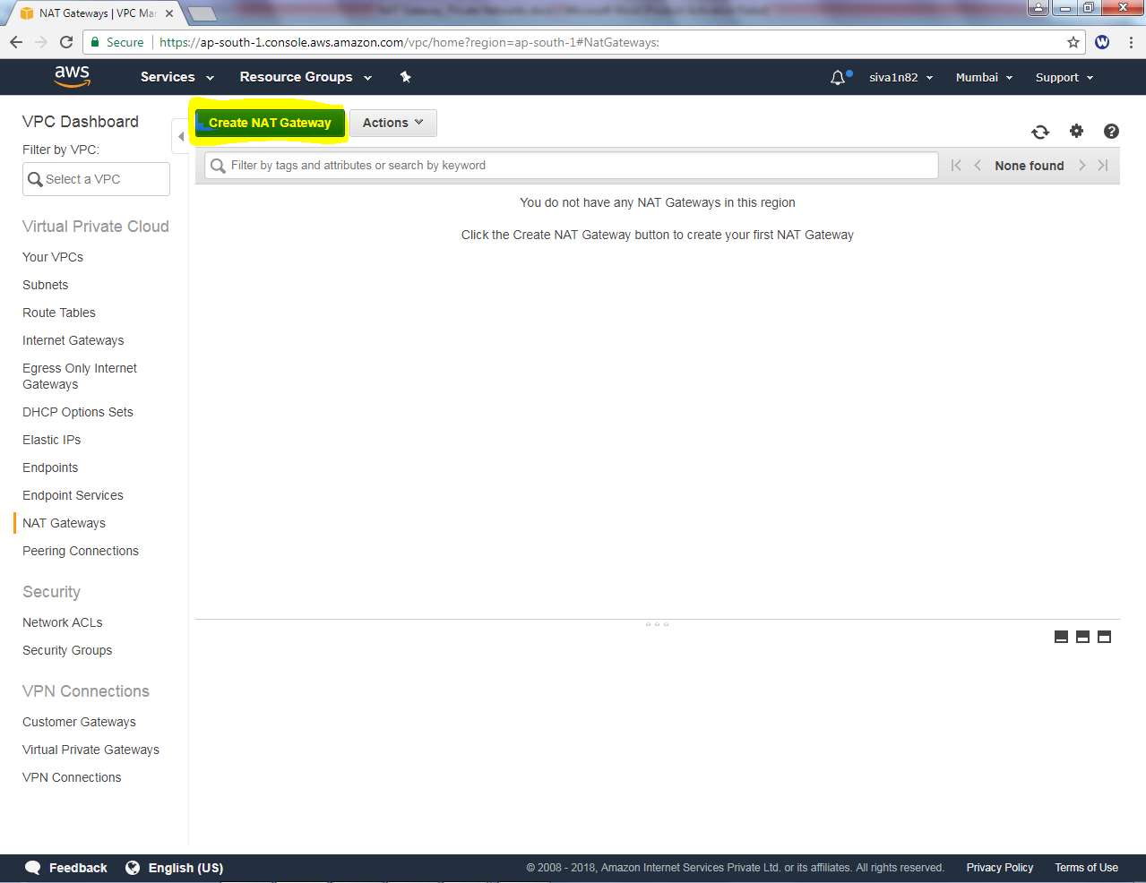

Click “Create NAT Gateway”.

While creating NAT Gateway, select **“Siva_Public_network”**

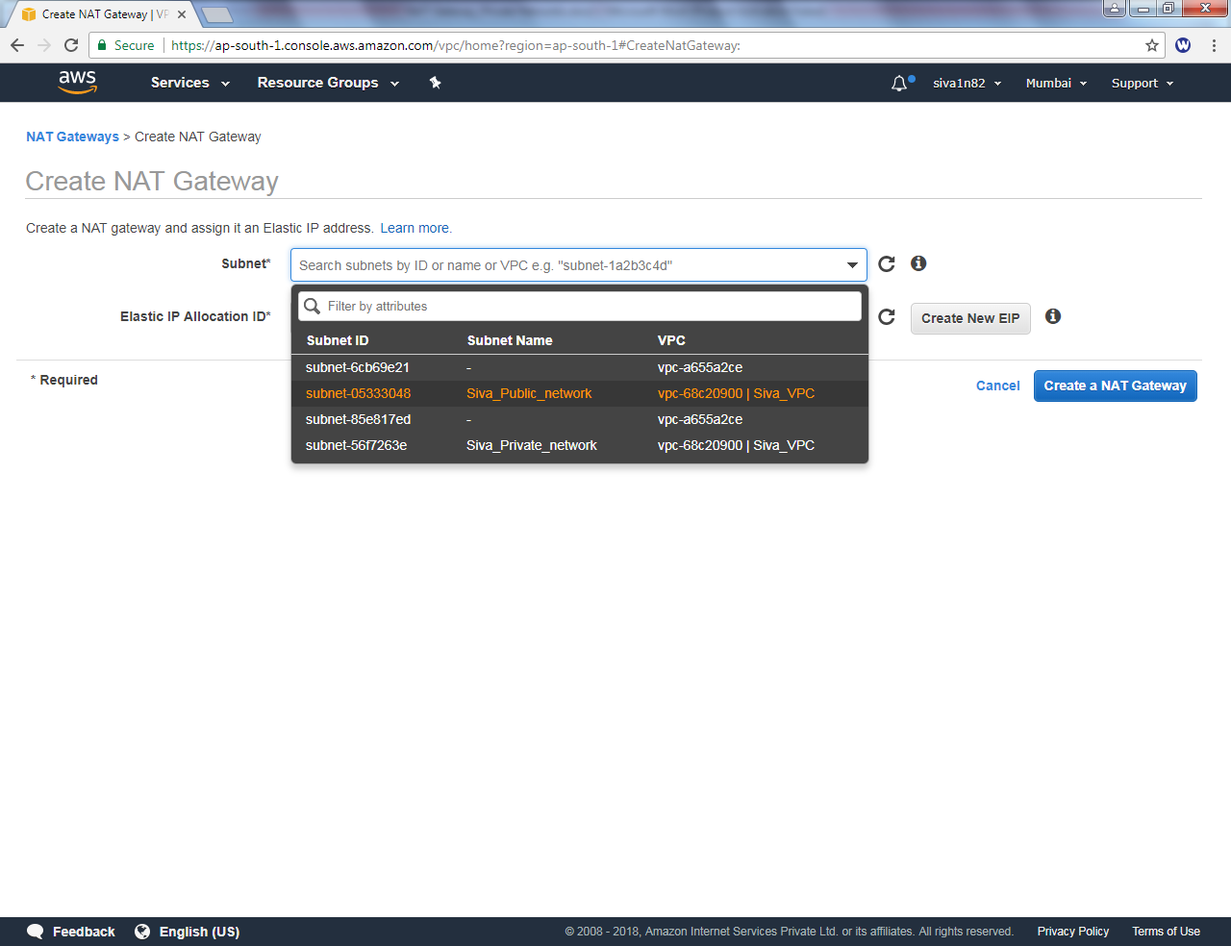

In Elastic IP Allocation ID, click “Create new ËIP”

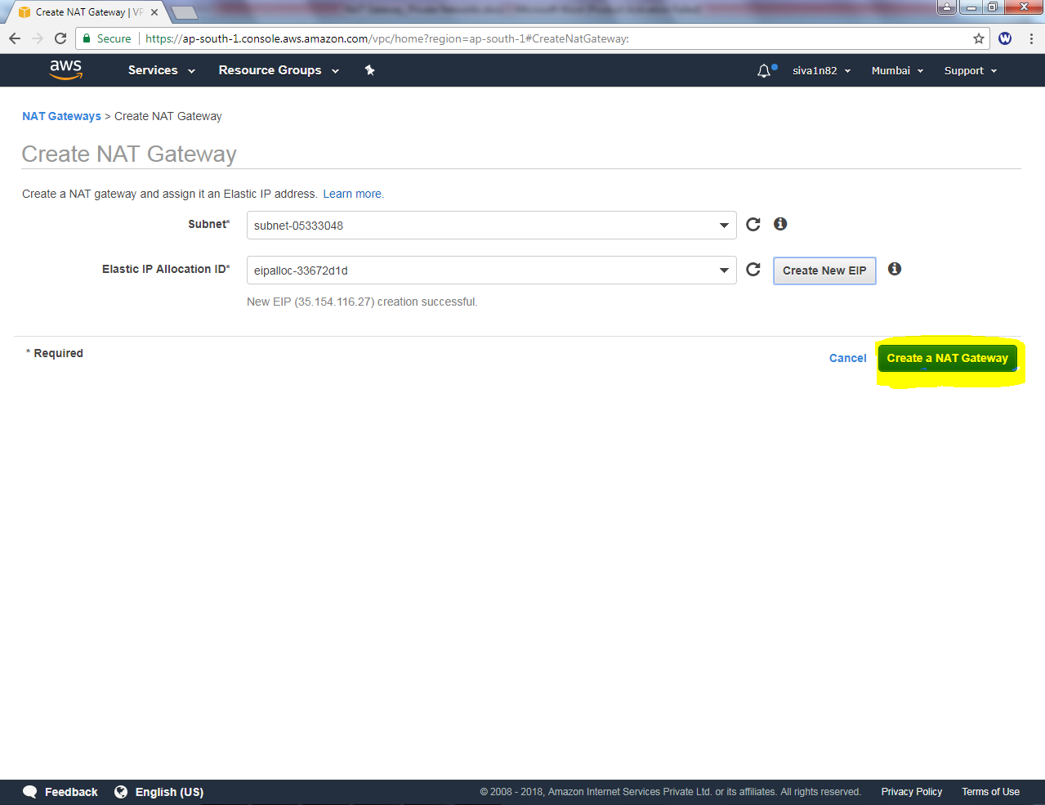

Then click “Create a NAT Gateway”.

We have required to create an routing table for private network.

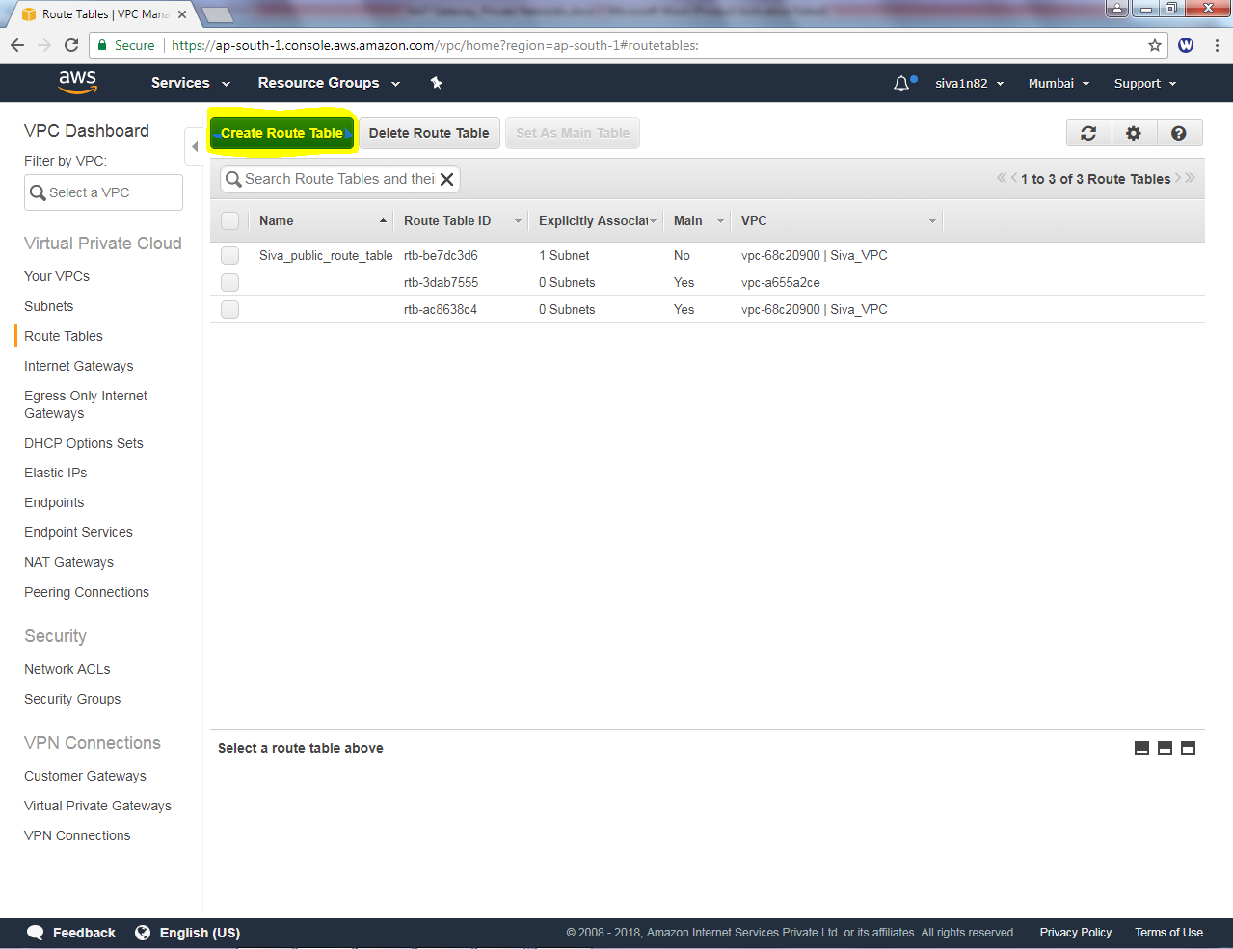

Click “Create Route Table”.

In Name tag, Type “siva_private_route_table” and select “Siva_VPC”.

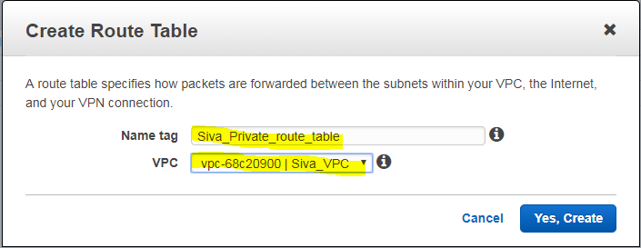

Then Click “**Yes create”**.

In Route Table, click edit button.

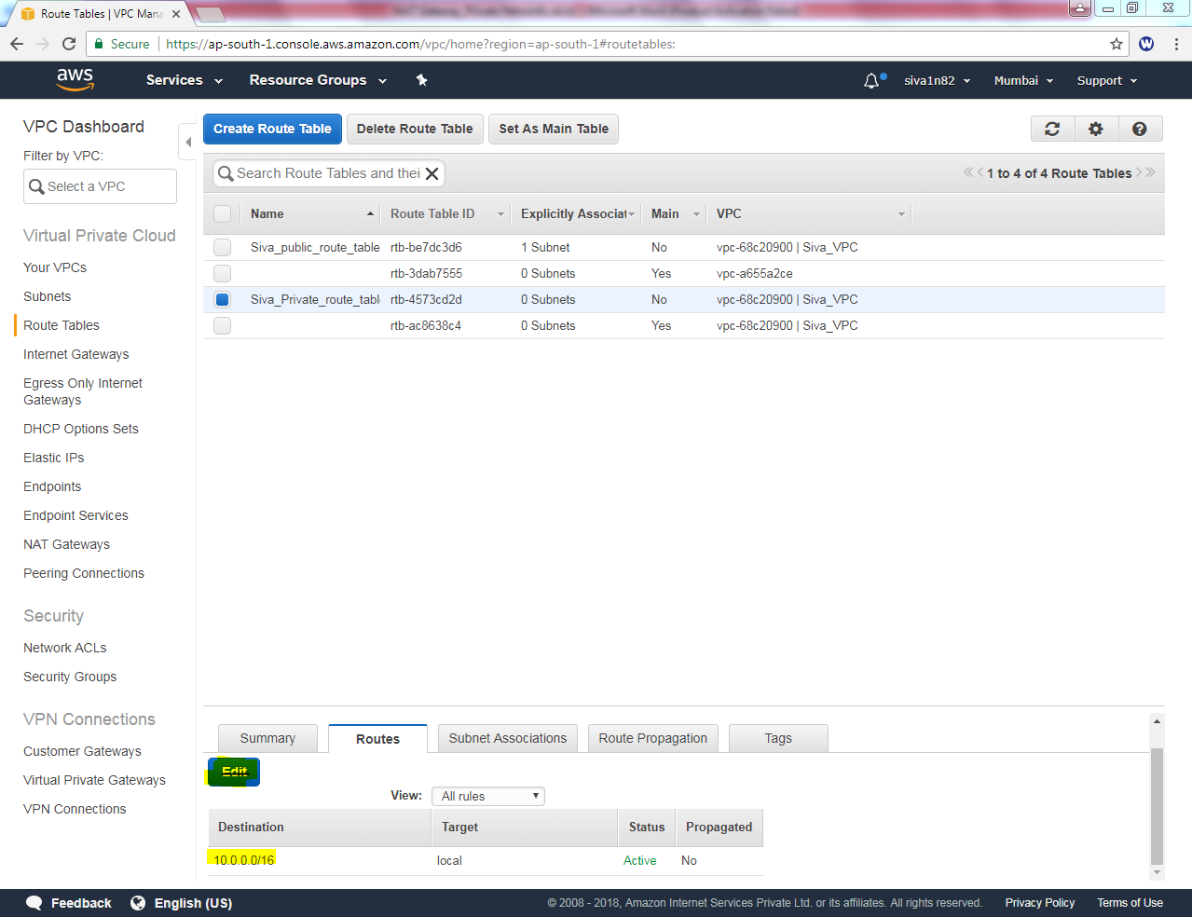

In Edit option, click “Add another route”

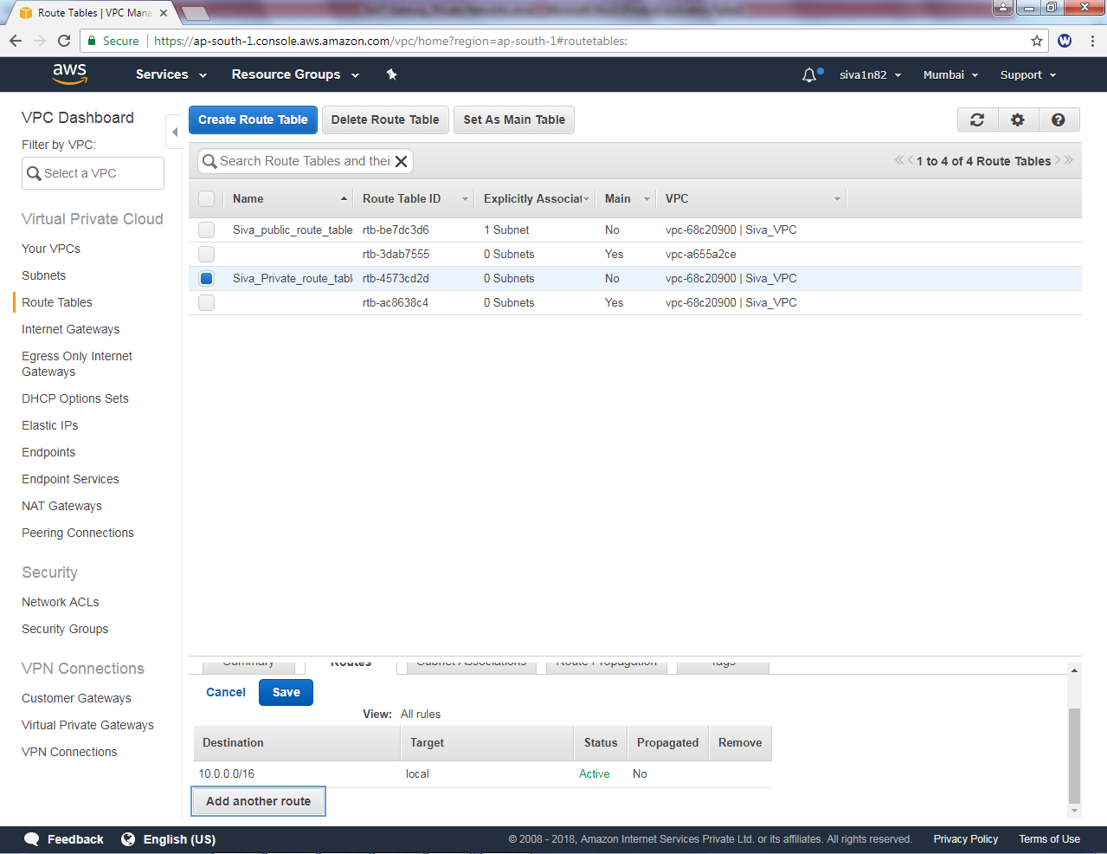

In add another route, enter the default route 0.0.0.0/0 with next hop address as nat-* as target.

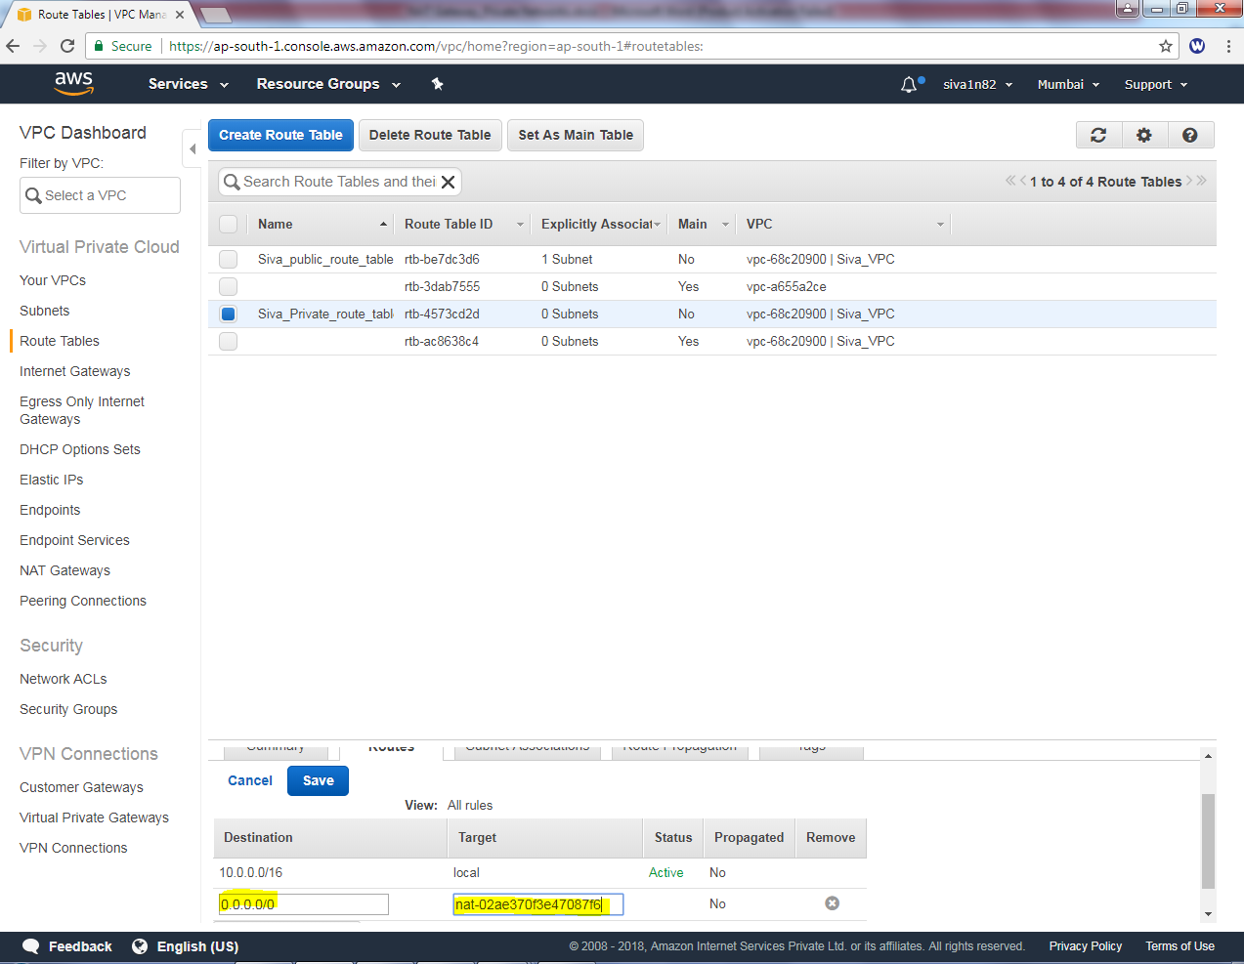

Click “save”.

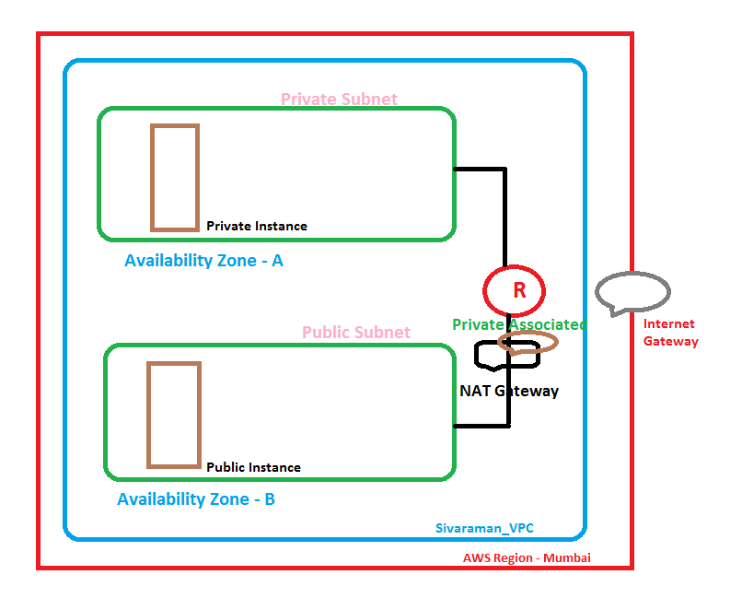

In Subnet associations., click “Edit”options

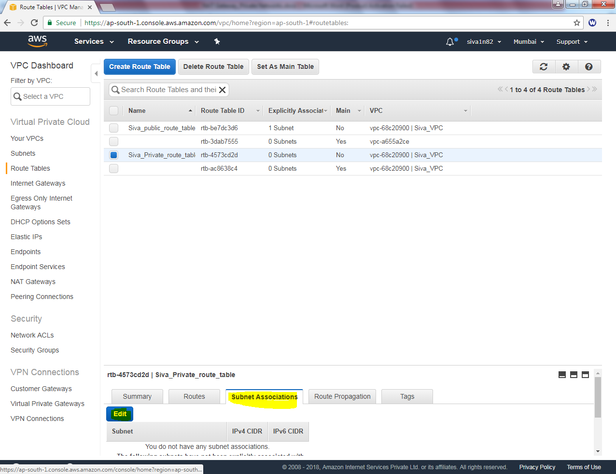

In Subnet associations, select “Siva_private_subnet” then click save.

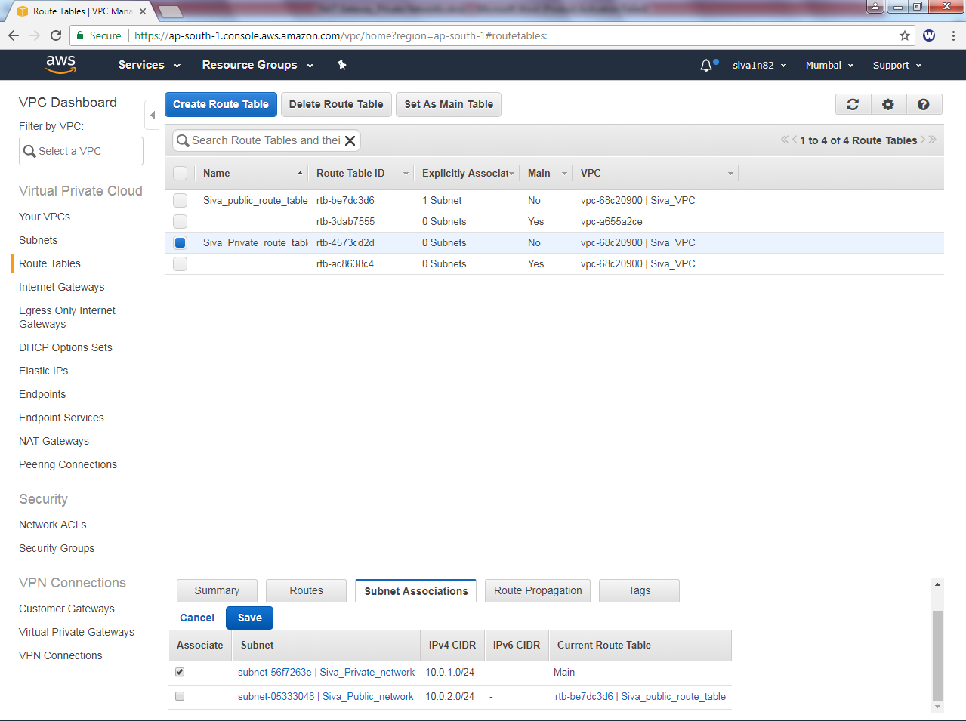

Now we are able to connect internet.

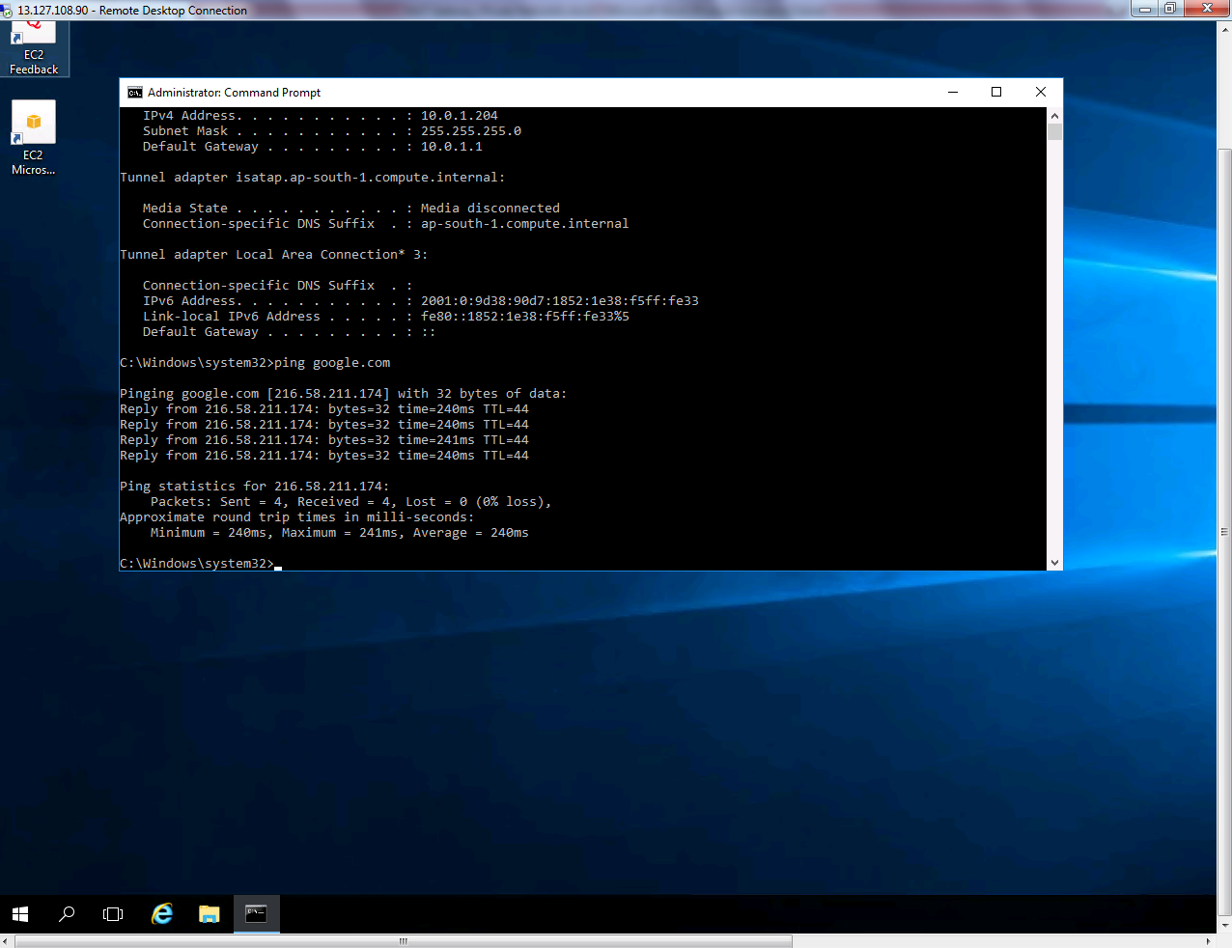

Now try to ping private subnet 10.0.1.204 from 10.0.2.14

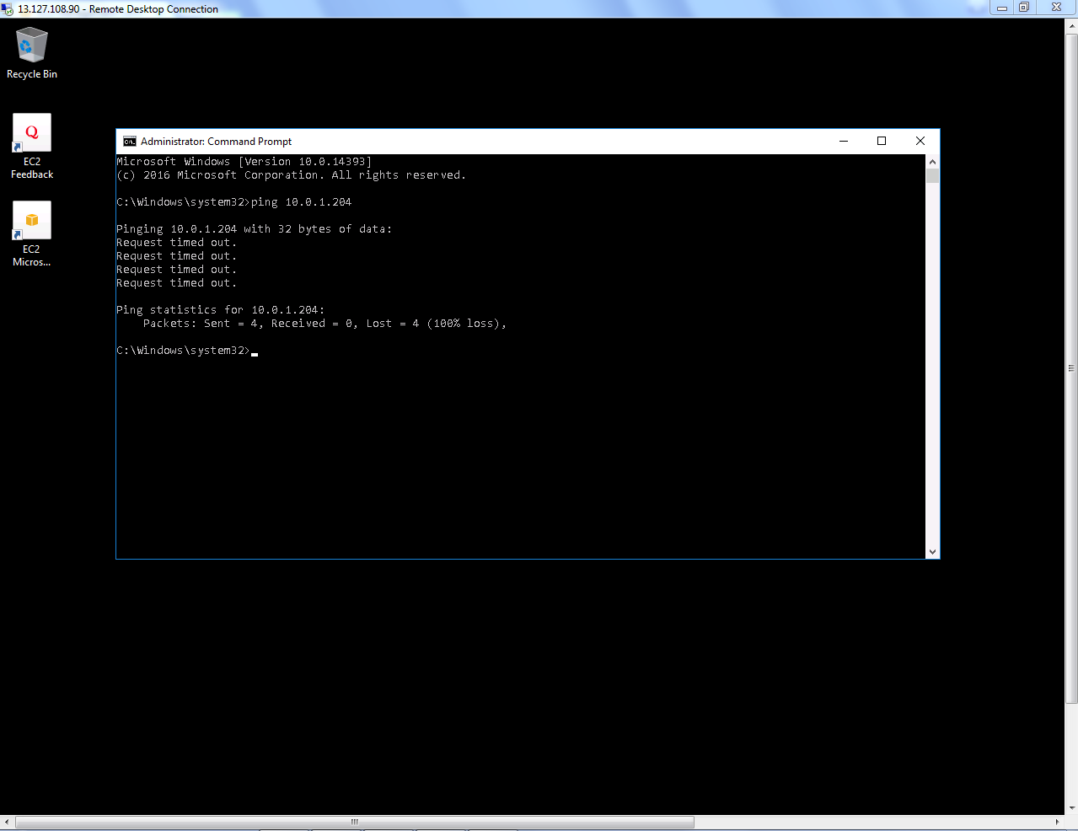

But, we are unable to ping what could be reason?

In Siva_Public_Sec_Group we have allowed only RDP port to inside the network. Hence we are unable to ping the private subnet 10.0.1.204 from 10.0.2.14.

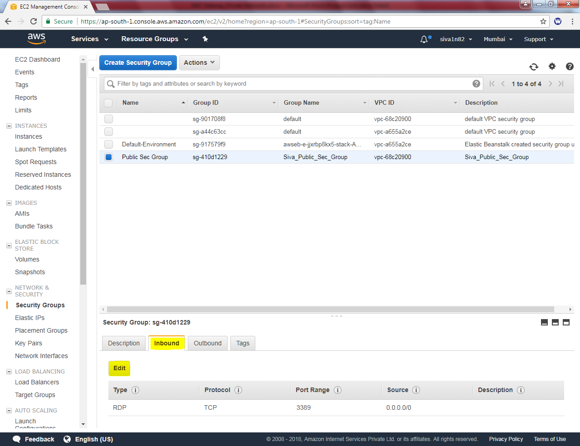

Click edit .

Then add rule **“Custom ICMP” “Protocol – All”** or **ICMP Echo Request** and Source 0.0.0.0/0 (any) network.

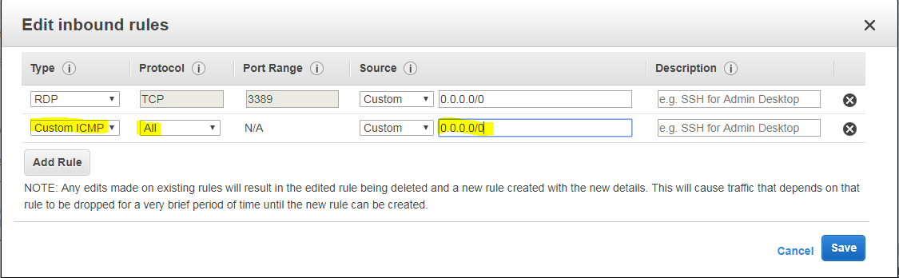

Try to ping 10.0.1.204 from 10.0.2.14 host. What could be the reason. Traffic ICMP has been allowed in Inbound rule. But server’s firewall is on, that is the reason for unable to ping the host.

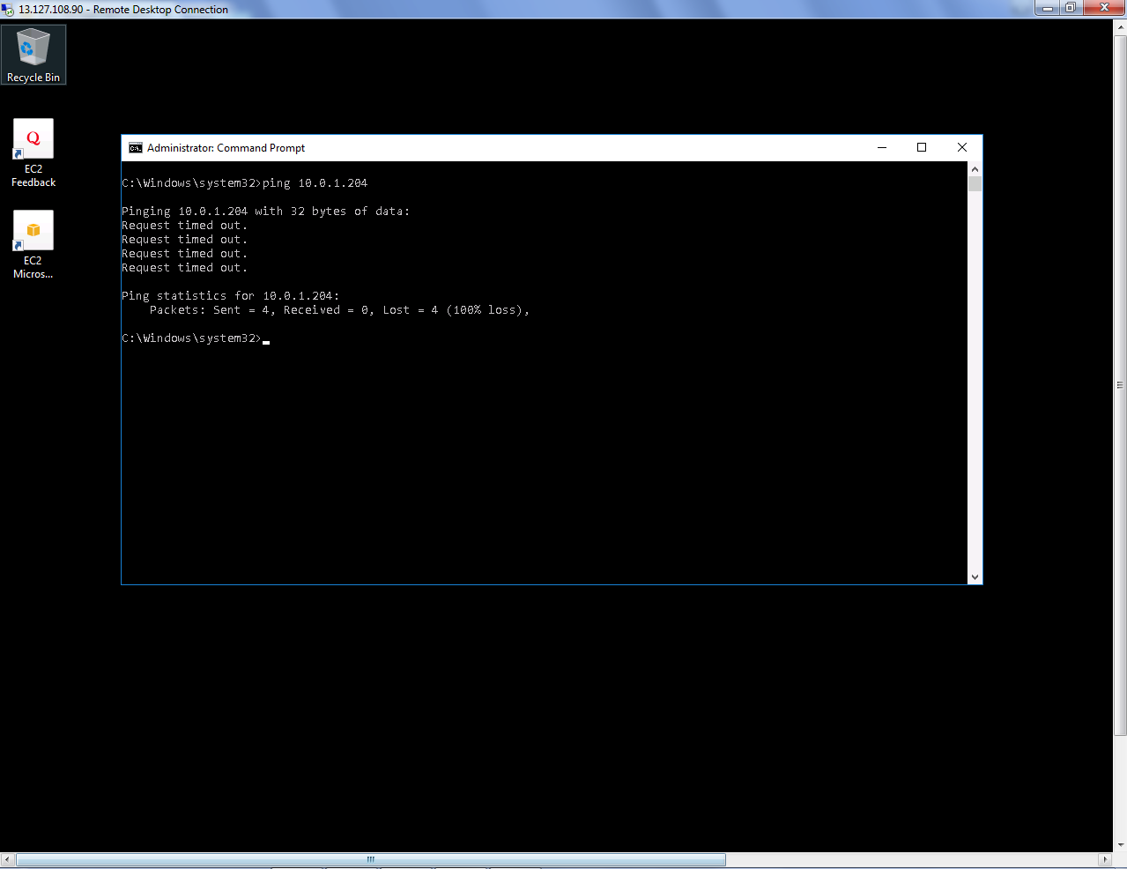

Hence, we need to turn off the windows firewall in both servers.

**Type Firewall.cpl**

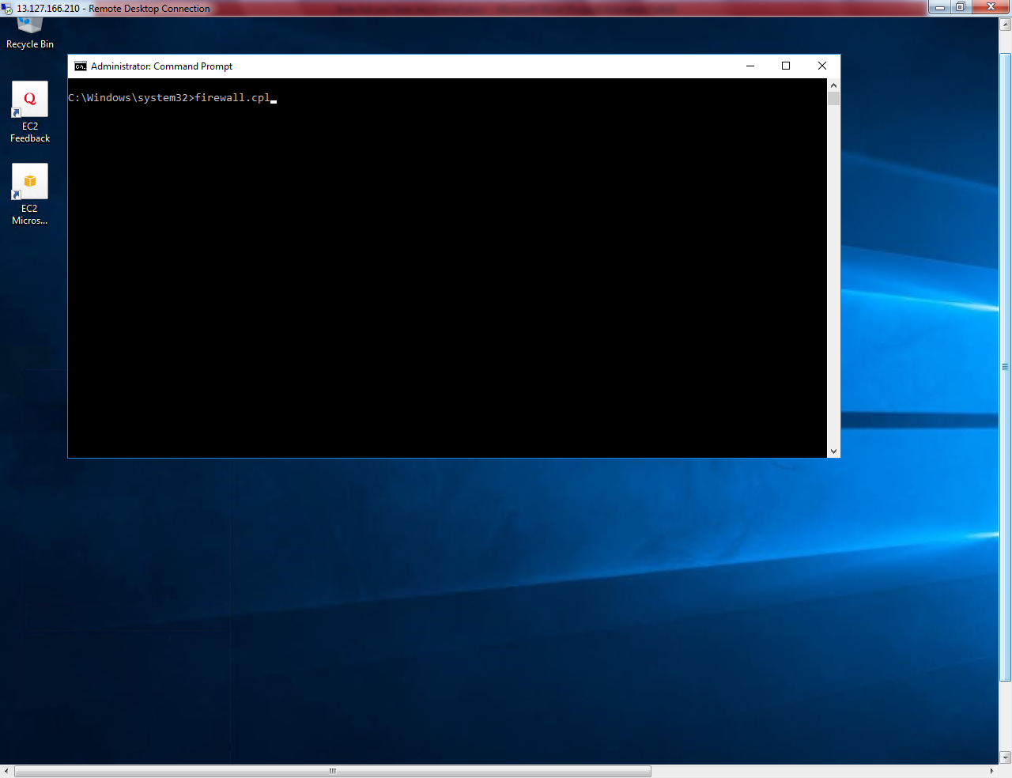

**Click “Turn Windows Firewall on or Off”.**

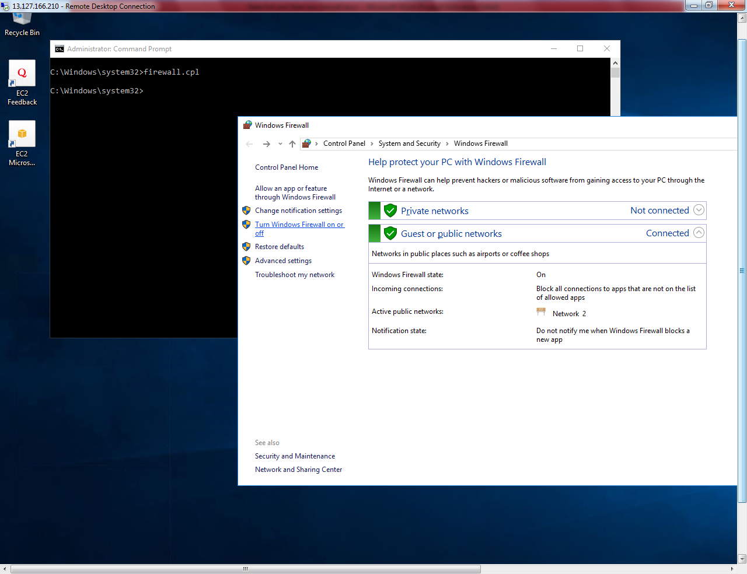

**Turn off windows firewall.**

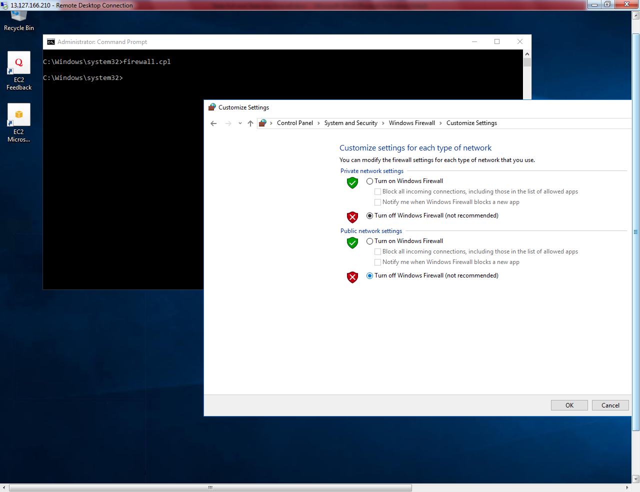

**Click ”Ok”.**

We can able to connect 10.0.2.14 host from 10.0.1.204.

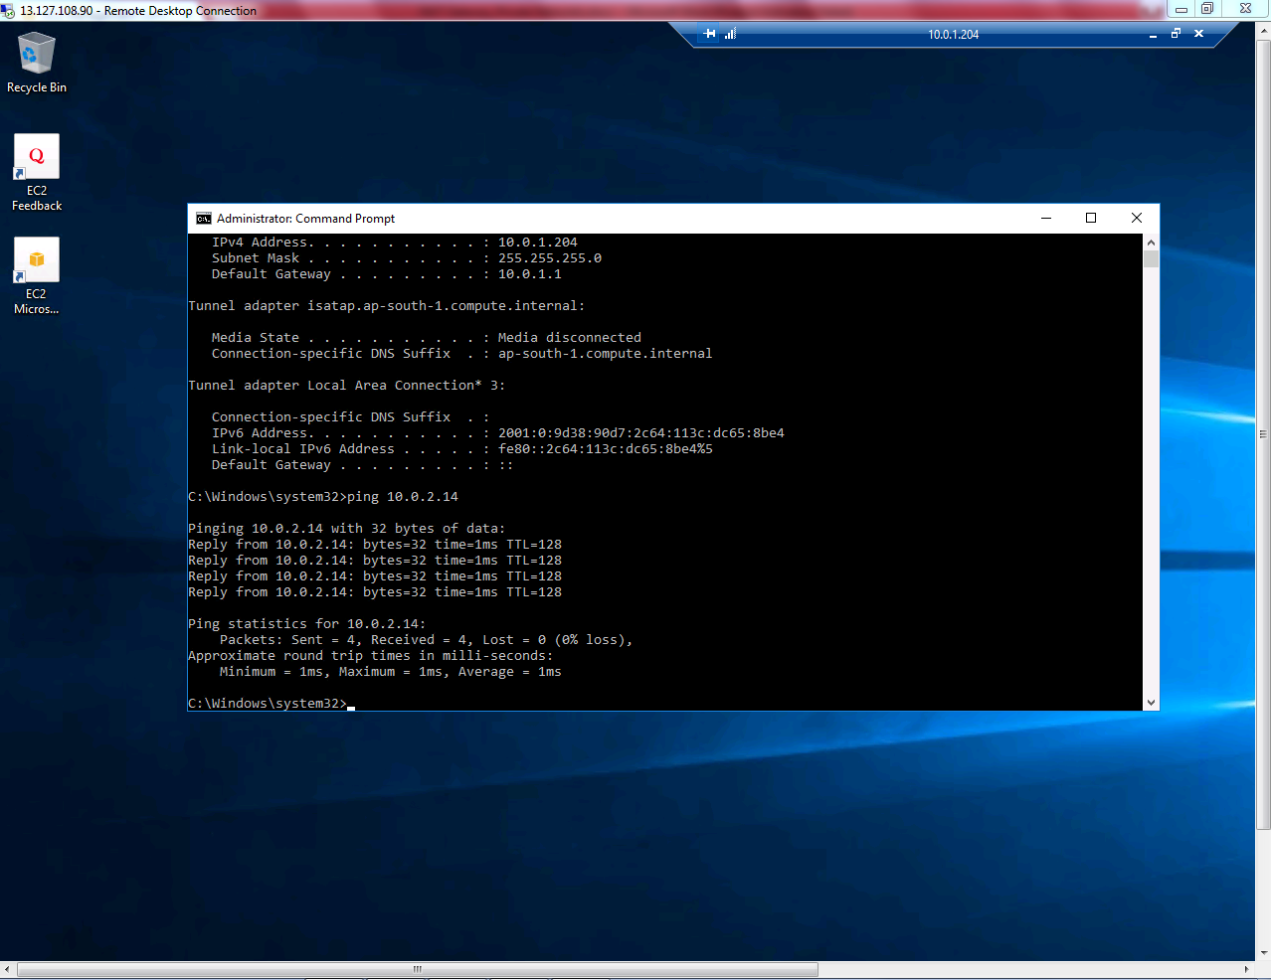

We can able ping 10.0.1.204 host from 10.0.2.14 host.

